Shorthand Notation of an Element
&
Composition of an Atom

Goal: You can determine the composition of an atom of any element from its atomic number and its mass number.
Tip: You must be aware of what the numbers on the periodic table mean and become familiar with the shorthand notation of writing the mass number and atomic number next to the symbol of the element.
An element in a Perodic table: Short hand notation of an element: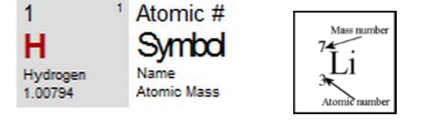
Atomic Number = number of Protons in the nucleus of the atom of that element.
Mass Number (atomic mass) = number of Protons and Neutrons in the nucleus of the atoms of that element.
Since atoms on the periodic table are electrically neutral # of electrons = # of Protons
One can represent an element using
- short hand notation: “chemical symbol” with w numbers written to its left: Subscript is atomic number and superscript is mass number (atomic mass).
OR
- Name of the element + mass number Lithium - 7

Always have a periodic table in front of you!!!!
Example: How many protons, electrons, and neutrons are in Beryllium? Write the shorthand notation for this element:
- Find Beryllium on the periodic table.
- Beryllium (Be), Atomic # = 4, Mass # = 9
- Neutrons = mass # - atomic # therefore, 9-4 = 5 neutrons
- Electrons = Protons because atoms are electrically neutral; 4 electrons.
- Shorthand notation: Beryllium – 9 or
9
Be
4
